How to Build A Sense of Belonging

in Your Life

This is about:
- The inherent human desire to feel accepted,
- Valued,
- & Supported;
- Along with the sense of security and stability that comes from being part of a group.
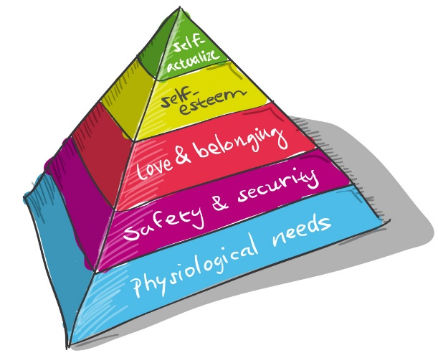
Abraham Maslow & The Hierarchy of Needs:

Belonging brings:
  - Increased happiness and well-being
  - Improved mental and physical health
  - Stronger sense of self-worth and purpose
  - Greater resilience in the face of challenges
It fosters
- feelings of happiness,
- it reduces stress, and
- boosts our immune system.
- When we feel connected to others, we have a stronger sense of self-worth
and purpose.
- This sense of belonging also provides us with a support network that
- helps us navigate life's challenges and
- bounce back from setbacks.
The metaphor of roots compared to friendship circles:
- Hidden Strength
- Nourishment and Growth
- Stability and Balance
- Interconnectedness
#1 Secret embedded in the Quest for the Holy Grail
- Parzifal the Hero
- The Fisher King, the maimed king
- The Wasteland
- Asking the RIGHT question:
Parzifal must ask, “What is the cause of your suffering?” The secret to the sense of belonging is to properly express compassion in your world.
The Quest for the Holy Grail teaches us that the answer is in asking the right question which is asking how we can show compassion to each other.
The Challenges of Belonging:
- Isolation.
- Feeling like an outsider in social circles
- Difficulty making friends or connecting with colleagues
- Major life transitions (moving, job change)
- Societal issues like discrimination or prejudice
How to Cultivate Belonging:

- Understanding and Empathy
- Motivation to Help
- Taking Action
The Power of Compassionate Action is:
- Reduced Suffering
- Stronger Relationships
- Personal Growth
- Creating a Ripple Effect
Specific ways we can put Compassion into Practice:
- Active Listening
- Offer Help
- Kind Words
- Volunteer
- Practice Patience

A Sense of Belonging and the Power of Connection
- Belonging is a fundamental human need.
- Connection fosters well-being and resilience.
- We can all cultivate a stronger sense of belonging.

